This is how you can help us:
If you would like to share a concern that you have on regulatory issues, or administrative rules that you would like us to review, submit a:

Petition for Regulatory Review
(201M-6, HRS)

or

Regulation for Review

For more information…

Contact us:
- http://sbrrb.hawaii.gov/
- DBEDT.sbrrb.info@hawaii.gov
- (808) 586-2419
- Small Business Regulatory
Review Board (SBRRB)
c/o DBEDT
P. O. Box 2359
Honolulu, HI 96804
- Visit our monthly meetings in Honolulu

- @SBRRBHI

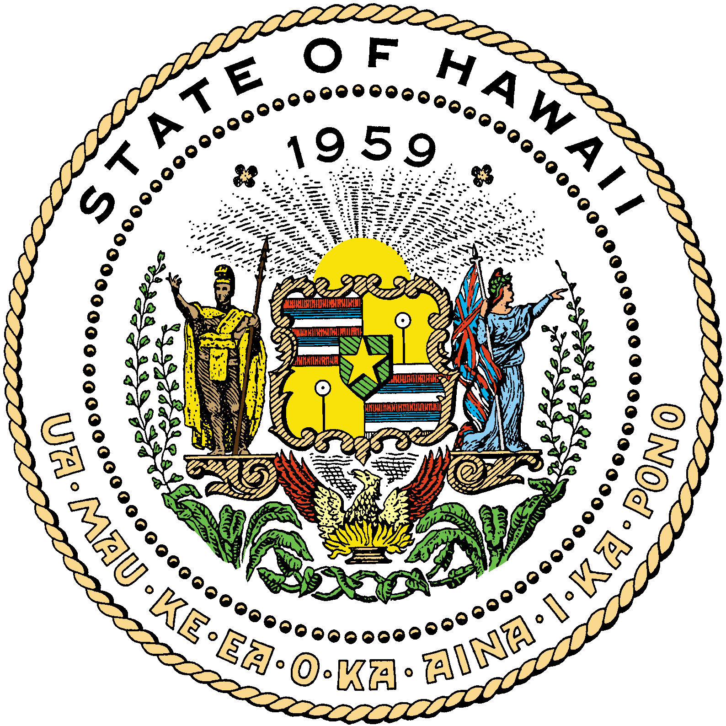
Small Business Regulatory Review Board
DBEDT
No. 1 Capitol District Building
250 South Hotel Street
Honolulu, HI 96813

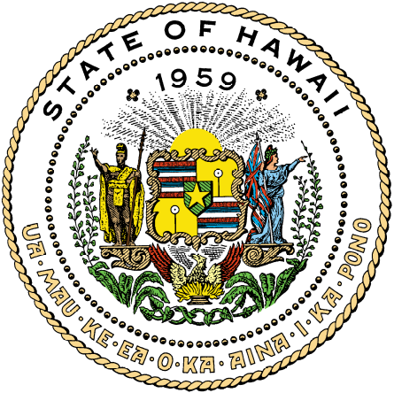

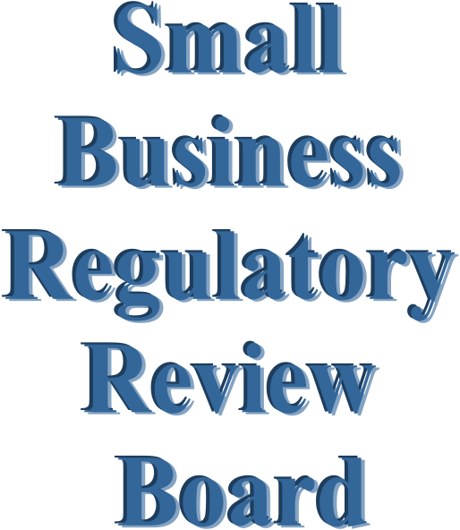

Purpose:
- The Small Business Regulatory Review Board (SBRRB) reviews proposed new or amended rules that impact small business*.
- The SBRRB makes recommendations to State Departments or the Legislature regarding the need for a rule change or legislation.
- For requests regarding County rules, the SBRRB may make recommendations to the County Council or the Mayor for appropriate action.

* “Small business,” under Chapter 201M, is defined, in part, as a for-profit enterprise consisting of fewer than one hundred full-time or part-time employees.

Who we are:
- Volunteers, appointed by the Governor and ratified by the Senate
- Small business owners/officers
Honolulu County
Robert Cundiff, Chair,

Hawai‘i County
Garth Yamanaka, Vice Chair,
Yamanaka Enterprises, Inc.

Kaua‘i County
William Lydgate, 2nd Vice Chair
Lydgate Farms

Honolulu County
Harris Nakamoto,
Kaiser Permanente Health Plan

Dr. Nancy Atmospera-Walch,
Advantage Health Care Provider, Inc.

Jonathan Shick,
Pono Consulting Group, LLC

Maui County
Mary Albitz,
FocalPoint Business Coach

Hawaii County
James Kimo Lee,
W.H. Shipman, Ltd.

DBEDT Director / Voting Ex-Officio

This is how we can help you!
- We review new and existing rules in conjunction with an impact statement on small business
- We review all rules that affect small businesses before and after public hearings, followed by our recommendations to the Governor
- We act as a resource to the State Legislature, State Departments and Counties regarding the small business impact of new laws, rules and ordinances
- We can also organize and hold conferences on problems affecting small businesses

We work with these State Departments:

- Accounting & General Services
- Agriculture
- Budget & Finance
- Business, Economic Development & Tourism
- Commerce & Consumer Affairs
- Education
- Hawaiian Home Lands
- Health
- Human Services
- Labor and Industrial Relations / HIOSH
- Land and Natural Resources
- Public Safety
- Taxation
- Transportation
- Office of the Attorney General
- Office of the Lieutenant Governor
- Public Utilities Commission
- University of Hawai‘i

“The SBRRB volunteer members
have a vital role to perform. Board
members join in serving the people of Hawai‘i and most importantly
represent their islands to support small business challenges and successes. We look forward to working with the Departments and Counties and helping to make positive and lasting changes to the small business community.”

Mahalo and Aloha,


~ Robert Cundiff, Chair

